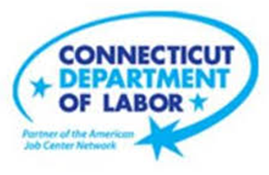

**NEW WEEKLY JOB POSTINGS FROM   
HELP WANTED ONLINE  
Office of Research**

**Week Ending March 13th, 2021 - New Ads Exceed Pre-Covid Levels**

WETHERSFIELD, March 19thth, 2021 – During the week ending March 13th, 2021, there were 7,465 new postings, up 19% ads from a week ago and up 86% from four weeks ago. This is the highest new ad count in over a year and is shown in the graph below exceeding the prior peak of 7,242 new ads for the week ending March 7th, 2020. This growth was driven by the Health Care & Social Assistance, Retail Trade, and Accommodation & Food Service industries, which accounted for a combined 41% of the 1,179 new ad increase over the week. Occupations with the largest over the week increase include Wholesale & Manufacturing Sales Representatives (+58 new ads or +38%), Security Guards (+56 new ads or +200%), and Medical & Health Service Managers (+52 new ads or +68%).

**Industries** with the most new postings include Health Care & Social Assistance, Retail Trade, and Manufacturing.

**Occupations** with the most new postings include Registered Nurses, Retail Salespersons, and Sales Representatives, Wholesale and Manufacturing.  
  
**Employers** with the most new postings include Hartford Healthcare, Yale-New Haven Health System, and the State of Connecticut.

**The three industries with the most new job postings where**

* **Health Care and Social Assistance** (1,440 new postings, +15% over the week)
* **Retail Trade** (735 new postings, +29% over the week)
* **Manufacturing** (586 new postings, -5% over the week)

­   
  
 Most sectors had job posting increases over the week ending March 13th. The largest over the week increases include Health Care & Social Assistance (+333 new ads or +26%), Retail Trade (+193 new ads or 15%), and Accommodation & Food Service (+125 new ads or +37%). Five sectors had a combined 105 new ad decrease over the week, Information (-60 new ads) had the largest decline. Every sector had ad increases over four weeks. Major sector four week increases include Health Care & Social Assistance (+767 new ads or +114%), Accommodation & Food Service (+352 new ads or +320%), and Manufacturing (+221 new ads or +61%).

For more information on total job ads by industry for Connecticut and its labor market areas, see the monthly report available here: <https://www1.ctdol.state.ct.us/lmi/hwol.asp>

**New Job Postings by Occupation**

 **The occupations with the most new postings were:**

* Registered Nurses (327 new postings, +6% over the week)
* Retail Salespersons (230 new postings, +14% over the week)
* Sales Representatives, Wholesale & Manufacturing (209 new postings, +38% over the week)

**Employers with the Most New Job Postings** 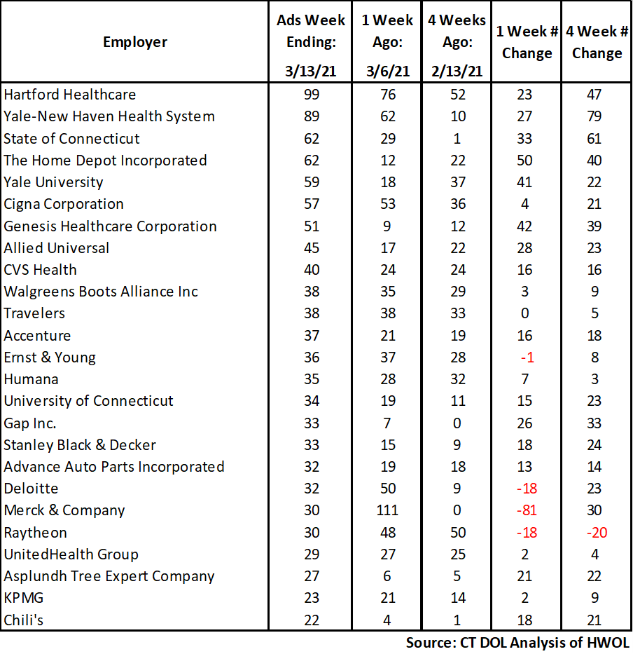

Employers with the most new job postings during the week ending March 13th, 2021 were mostly in Finance & Insurance, Retail Trade, and Health Care. The 25 employers shown above account for 14 percent of all new ads. Of the top 25 employers, 21 had over the week increases and 4 had decreases. Among the 21 increasing employers, the largest occurred at The Home Depot (+50 new ads), Genesis Healthcare Corporation (+42 new ads) and Yale University (+41 new ads). All but one employer in the top 25 increased over four weeks, the largest were Yale-New Haven Health System (+79 new ads), the State of Connecticut (+61 new ads), and Hartford Healthcare (+47 new ads).  
 **Covid-19 and Weekly New Job Postings**  
In recent months, the pandemic Coronavirus (Covid-19) has caused significant social and economic implications throughout the world. This HWOL report includes new weekly job postings to illustrate how Covid-19 has impacted Connecticut in the short term and highlight recent job postings in the weeks since the virus disrupted both the economy and labor markets.  
  
**What is HWOL?**The **Conference Board Help Wanted Online**® Data Series (HWOL) measures the number of new, first-time Online job postings and jobs reposted from the previous month for over 16,000 Internet job boards, corporate boards and smaller job sites that serve niche markets and smaller geographic areas. To view more HWOL data, go to: [**https://www1.ctdol.state.ct.us/lmi/pubs/HWOL2020.pdf**](https://www1.ctdol.state.ct.us/lmi/pubs/HWOL2020.pdf)